MARKET ENTRY ASSESSMENT
India E-Commerce Smartwatch &
Fitness Tracker Market Analysis
Competitive Landscape • Pricing Dynamics • Strategic Recommendation
September 2024 │ Prepared for Internal Strategy Review

450 | 18 | ₹4,145 | 22%
Product Listings Analysed | Brands in Dataset | Demand-Weighted ASP | Mid-Tier Listing Share

RECOMMENDATION: GO — Mid-Tier Market Entry at ₹10,000–₹15,000
The mid-tier segment is fragmented, under-engaged, and exhibits stable pricing discipline. A new entrant offering premium features at mid-tier prices occupies the strongest available whitespace in India's e-commerce wearables channel.

Data Sources: India e-commerce smartwatch dataset (450 listings, 18 brands, Flipkart/Amazon); Quick Research external findings on global vendor share, segment trends, and ASP dynamics (2024).
Analytical Basis: Dataset statistics cross-referenced with external research. Ratings count used as demand proxy. Demand-weighted ASP calculated by consumer ratings weighting.

Executive Summary
India's e-commerce smartwatch and fitness tracker market is a dynamic, multi-tier arena with 450 active product listings across 18 brands on major platforms (Flipkart/Amazon). The market presents a clear three-tier structure—budget, mid-tier, and premium—each with distinct competitive dynamics, pricing behaviour, and consumer engagement profiles. This report synthesises a 450-listing dataset with external Quick Research findings to deliver a data-driven market entry recommendation.

Core Finding: GO at ₹10K–₹15K
After rigorous analysis of competitive density, pricing stability, consumer engagement signals, and feature differentiation potential, this assessment concludes:
► GO RECOMMENDATION: Mid-Tier Entry at ₹10,000–₹15,000 (ASP target: ~₹12,500)

The budget segment is dominated by well-entrenched Indian brands (Fire-Boltt, Noise, boAt) in a race-to-the-bottom pricing spiral with 59% average discounts. The premium segment is locked behind Apple, Garmin, and Samsung ecosystem barriers. The mid-tier represents the clearest whitespace: fragmented across 13 brands, under-indexed in consumer engagement (22% of listings, only 5% of total ratings), and exhibiting stable pricing discipline with 35% average discount vs. 59% in budget.

Headline Metrics
Metric | Dataset Finding | Strategic Implication
Total listings analysed | 450 products, 18 brands | Broad competitive base; no single dominant player
Budget segment share | 57.3% of listings, ~90% of ratings | Volume exists but margins are structurally challenged
Mid-tier segment | 22.3% of listings, ~5% of ratings | Under-engaged → opportunity for strong entrant to capture share
Premium segment | 20.5% of listings, avg. rating 4.4 | High satisfaction; high barrier to entry (ecosystem lock-in)
Demand-weighted ASP | ₹4,145 (vs. simple ASP ₹12,748) | Actual consumer spend concentrated in budget; mid-tier under-penetrated
Mid-tier pricing stability | DW-ASP ₹13,642 ≈ Simple ASP ₹12,931 | Less promotional warfare; margin protection viable
Recommended entry price | ₹10,000–₹15,000 | Bridges mid-tier sweet spot; competes on features, not discounts

Key Risks to Monitor
- Mid-tier engagement gap: Low ratings count may signal structurally small segment or chronic under-marketing by incumbents. Entry requires differentiation and sustained marketing investment.
- Budget brand upward migration: Fire-Boltt, Noise, and boAt are extending SKUs toward ₹5K–₹7K, compressing the lower mid-tier boundary.
- Premium downward pressure: Samsung and Fitbit products compete at ₹20K–₹25K, limiting upper mid-tier headroom.
- Data limitation: Dataset is a cross-sectional snapshot (no time-series); India e-commerce channel only, not brick-and-mortar or offline.

Section 1: Competitive Landscape Summary
The India e-commerce smartwatch market is defined by a highly asymmetric three-tier structure. Eighteen brands compete across 450 product listings, with distinct clusters of competitive intensity at the budget, mid-tier, and premium price points. Understanding this landscape is fundamental to identifying the optimal entry strategy.

1.1 Market Structure Overview
The market is moderately fragmented but with pronounced concentration at the extremes. The top three brands (Fire-Boltt, Noise, Garmin) account for approximately 32% of all listings, while the top five brands account for 46.4%. This concentration is highest in the budget and premium segments, while the mid-tier remains genuinely fragmented—a structural characteristic that favours new entrants.
Tier | Price Band | Product Listings | Share | Avg. Rating
Budget | < ₹5,000 | 252 | 57.3% | 3.9
Mid-Tier | ₹5,000–₹20,000 | 98 | 22.3% | 4.1
Premium | > ₹20,000 | 90 | 20.5% | 4.4
TOTAL | ₹1,199–₹1,39,990 | 440 (priced) | 100% | 4.1

1.2 Brand Mapping by Tier

Budget Segment (< ₹5K) — High Volume, Indian Brand Dominance
The budget segment is characterised by aggressive SKU proliferation and heavy discounting from Indian-origin brands. Five brands account for the overwhelming majority of budget listings:
Brand | SKUs | Listing Share | ASP (₹) | Avg. Discount
Fire-Boltt | 52 | 11.6% | 3,280 | 65%
Noise | 42 | 9.3% | 4,029 | 60%
boAt | 31 | 6.9% | 2,094 | 72%
Pebble | 31 | 6.9% | 3,637 | 44%
Zebronics | 31 | 6.9% | 2,729 | 53%

These five brands together hold ~41.6% of all product listings in the dataset. Their combined dominance, aggressive discounting practices (averaging 59.2% across the budget tier), and low ASPs create a structural margin barrier that makes budget entry fundamentally unattractive for a new entrant without massive scale advantages.

Mid-Tier Segment (₹5K–₹20K) — Fragmented, Global-Brand Presence
The mid-tier hosts a diverse mix of global lifestyle and technology brands without a clear dominant player. This fragmentation is the defining characteristic that creates the whitespace opportunity:
Brand | Mid-Tier SKUs | Dataset Share | ASP (₹) | Avg. Discount
Fossil | 23 | 5.1% | 15,233 | 38%
Samsung (mid) | 13 | 2.9% | ~15,000–18,000 | ~28%
Honor | 12 | 2.7% | 10,374 | 20%
Huawei | 12 | 2.7% | 15,159 | 40%
Fitbit (mid) | 11 | 2.4% | 17,698 | 23%
Amazfit | 10 | 2.2% | 10,085 | 34%

No single brand commands more than 5% listing share in the mid-tier. This is in stark contrast to the budget segment (Fire-Boltt at 11.6%) and the premium segment (Garmin at 8.4%). The mid-tier's fragmentation means that a well-positioned new entrant does not face an entrenched category leader.

Premium Segment (> ₹20K) — Consolidated, Ecosystem-Driven
The premium segment is firmly controlled by three global technology incumbents with powerful ecosystem advantages:
Brand | Premium SKUs | Dataset Share | ASP (₹) | Avg. Discount
Garmin | 34 | 7.6% | 45,227 | 16%
Apple | 26 | 5.8% | 43,161 | 2%
Samsung | 16 | 3.6% | 25,312 | 28%
Fitbit | 9 | 2.0% | ~22,000–26,000 | 23%

Apple's near-zero discount rate (2%) is the most visible indicator of premium brand equity in the market. Garmin's breadth (34 SKUs, range ₹16,990–₹1,39,990) reflects its outdoor/fitness specialisation. Together, these brands create an ecosystem barrier that requires years of investment to replicate. The premium segment is not a viable entry point for a new brand.

1.3 Vendor Share Visualisation
The chart below illustrates listing share distribution across all 18 brands. The concentration of Indian budget brands in the upper half of the distribution is clearly visible, contrasted with the scattered presence of global brands across smaller SKU portfolios.
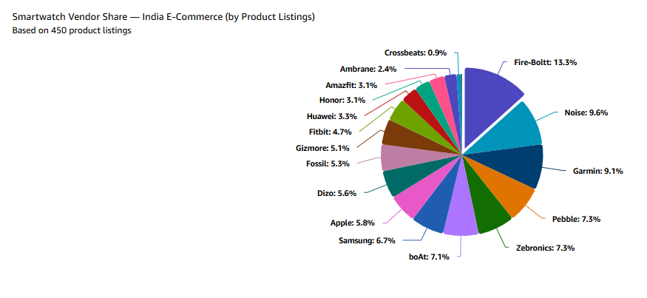
Figure 1: Smartwatch Vendor Share — India E-Commerce by Product Listings (450 listings, 18 brands)

1.4 Brand ASP Ranking
Average Selling Price varies enormously across brands—from ₹1,799 (Hammer) at the floor to ₹45,227 (Garmin) at the ceiling. This 25x price range illustrates the vast diversity of the competitive landscape. Critically, the ₹10K–₹15K range contains only Amazfit (₹10,085) and Honor (₹10,374) as natural anchors, confirming limited competition at the recommended entry price point.
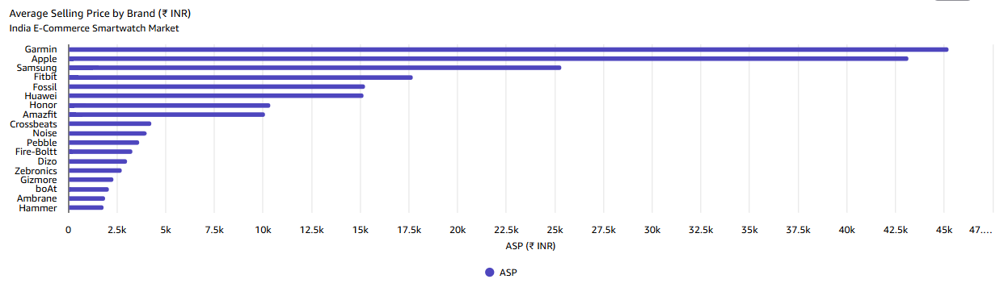
Figure 2: Average Selling Price by Brand (₹ INR) — Garmin commands highest ASP at ₹45,227; recommended entry zone ₹10K–₹15K sits between Honor/Amazfit and Samsung/Fitbit
The ASP spectrum also reveals pricing discipline by tier: budget brands cluster densely below ₹5,000 while premium brands stand well above ₹20,000. The mid-tier space between ₹10K–₹15K is distinctly uncrowded relative to the density of listing activity at either extreme.

1.5 Cross-Reference: External Research vs. Dataset
The Quick Research external findings align closely with the dataset analysis, providing corroboration across both product listing share and broader competitive dynamics:
Competitive Claim | Dataset Evidence | External Research Corroboration
Indian brands dominate budget listings | Fire-Boltt 13.3%, Noise 9.6%, boAt 7.1% of all listings | External research confirms: Indian budget brands together ~30% listing share
Mid-tier is fragmented | No mid-tier brand exceeds 5% share; 13 brands compete | External: "Mid-tier is fragmented — Amazfit, Huawei, Honor, Fitbit each 3–5%"
Apple maintains price integrity | Apple avg. discount: 2%, rating: 5.0/5 | Consistent with global premium positioning; no contradiction in external data
Garmin specialises in outdoor/premium | Garmin: 34 premium SKUs, range up to ₹1,39,990, avg. rating 4.0 | External: "Garmin commands highest ASP with outdoor/fitness niche"

Section 2: Key Trends and Signals
This section synthesises the dataset's quantitative patterns with external market research findings to identify the structural forces shaping India's e-commerce wearables market. Three clusters of signals are examined: pricing dynamics, consumer engagement patterns, and product and feature trends.

2.1 Pricing Dynamics

Budget Segment — Race to the Bottom
The budget segment displays the most extreme pricing behaviour in the market. Original prices average ₹6,972 but sell at ₹2,631—a 62% effective gap that signals unsustainable margin pressure at scale. The demand-weighted ASP (calculated by weighting prices by consumer ratings as a demand proxy) reveals an even more concerning picture: the products that actually sell in volume have an average price of only ₹1,863, indicating that the highest-volume SKUs are priced well below the segment average.
- boAt (ASP ₹2,094, avg. discount 72%) and Ambrane (ASP ₹1,896, avg. discount 61%) represent the floor of viable consumer pricing in the market.
- Fire-Boltt (65% avg. discount, 52 budget SKUs) compensates for margin compression through SKU volume—a strategy unavailable to new entrants.
- Maximum discounts reach 91% in the budget segment—extreme promotional activity that distorts nominal pricing.

External research corroborates: "Price erosion is severe: original prices average ₹6,972 but sell at ₹2,631—a 62% gap that signals unsustainable margin pressure." This is not a cyclical phenomenon but a structural characteristic of the budget segment in India's e-commerce channel.

Mid-Tier — Stable Pricing, Disciplined Discounting
The mid-tier stands in sharp contrast. The key indicator of pricing health is the convergence of simple ASP and demand-weighted ASP:
Segment | Simple ASP (₹) | Demand-Weighted ASP (₹) | Gap
Budget (< ₹5K) | 2,631 | 1,863 | −29%
Mid-Tier (₹5K–₹20K) | 12,931 | 13,642 | +5%
Premium (> ₹20K) | 40,874 | 36,392 | −11%

The mid-tier's demand-weighted ASP (₹13,642) is actually slightly above the simple ASP (₹12,931)—a positive signal indicating that mid-tier consumers are willing to pay at or above the average price point. This is categorically different from the budget pattern, where the best-selling products are the cheapest. It means a new entrant can price competitively in the mid-tier without triggering a margin-destroying discount war.

Premium — Brand Equity Enables Price Integrity
The premium segment demonstrates that brand investment translates directly into pricing power. Apple's 2% average discount is the lowest in the market and stands as a benchmark of brand equity. Garmin's 16% average discount reflects the occasional promotional activity on older outdoor-focused SKUs while maintaining a ₹45,227 ASP. Samsung, the most promotional of the three at 28%, still maintains strong price positioning relative to the market.

Full ASP and Discount Comparison (Visual Evidence)
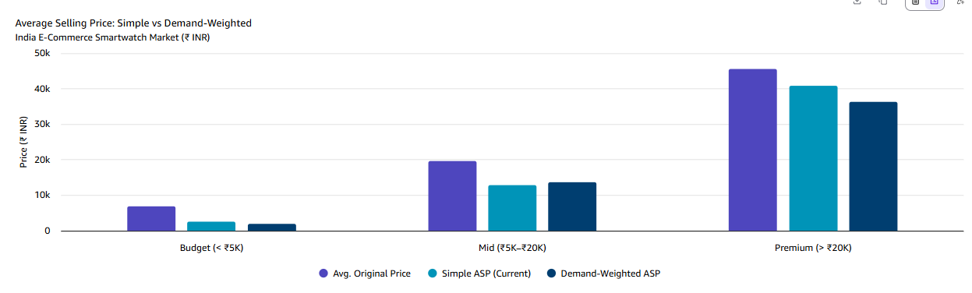
Figure 3: Average Selling Price — Simple vs Demand-Weighted by Tier (₹ INR). Note mid-tier DW-ASP exceeds simple ASP, a positive pricing health signal.
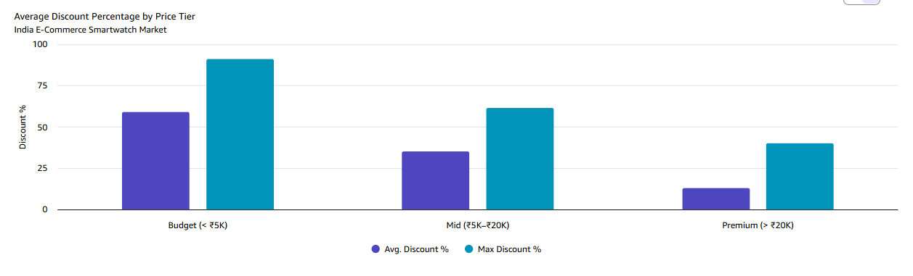
Figure 4: Average and Maximum Discount % by Price Tier. Budget discounting (avg. 59.2%, max 91%) dwarfs mid-tier (avg. 35.1%) and premium (avg. 12.9%).

2.2 Consumer Engagement Patterns
Consumer ratings count is used as a demand proxy—the higher the ratings volume, the more units a product has sold. This metric reveals a fundamental imbalance between listing share and actual consumer demand:
Tier | Total Consumer Ratings | Avg. Ratings/Product | Rating Share | Avg. Score
Budget (< ₹5K) | 4,038,046 | 18,355 | ~90.1% | 3.9
Mid-Tier (₹5K–₹20K) | 233,001 | 2,841 | ~5.2% | 4.1
Premium (> ₹20K) | 217,112 | 2,680 | ~4.8% | 4.4

The budget segment commands 90% of total consumer ratings despite holding only 57% of product listings—confirming that actual purchase volume is even more concentrated in the budget tier than listing share suggests. Budget products average 18,355 ratings each; mid-tier products average only 2,841. This 6.5x gap is a critical signal.
However, the mid-tier engagement gap should be interpreted carefully. Two explanations are plausible:
- Structural limitation: The mid-tier may represent a genuinely smaller addressable market in India's e-commerce channel, where most buyers are price-sensitive.
- Under-marketing opportunity: Current mid-tier incumbents (Fossil, Honor, Huawei) may be under-investing in digital marketing and discoverability, leaving demand unmet. The mid-tier's strong average satisfaction score (4.1) suggests that the products that do reach consumers are well-received.

External research characterises this as a "fragmented opportunity—lower consumer engagement relative to shelf space." A new entrant with a superior digital marketing strategy could potentially unlock latent demand that current players are failing to capture.
Premium satisfaction scores (4.4 average, Apple at 5.0) confirm that established brand equity delivers the highest quality perception. The budget segment's lower score (3.9) reflects the inherent quality trade-offs at ₹2,000–₹3,000 price points. Mid-tier's 4.1 score, achieved at a fraction of the premium cost, is a genuine value proposition for consumers considering an upgrade from budget devices.
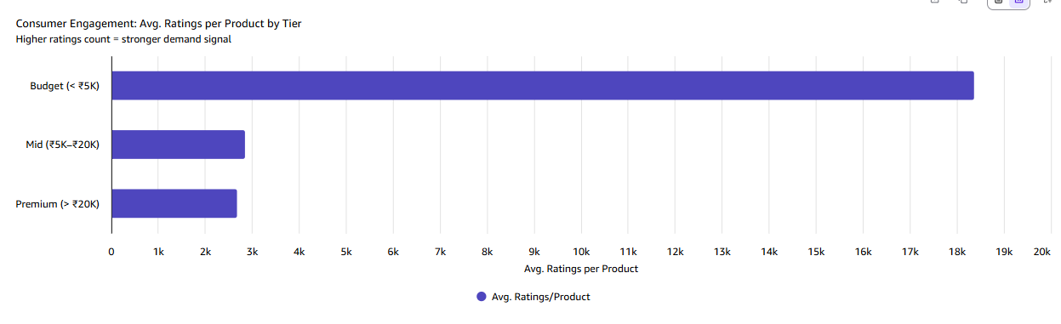
Figure 5: Consumer Engagement — Average Ratings per Product by Tier. Budget products average 18,355 ratings each vs. 2,841 for mid-tier, a 6.5x demand volume difference.

2.3 Product and Feature Trends
Feature positioning shifts materially across tiers, creating a clear design language for each segment. Understanding these distinctions is essential for positioning a new product within the mid-tier sweet spot while differentiating from budget mass-market offerings.
Feature Dimension | Budget (< ₹5K) | Mid-Tier (₹5K–₹20K) | Premium (> ₹20K)
Touchscreen | 92.9% | 80.6% | 76.7%
Bluetooth | 100% | 94.9% | 95.6%
Dominant Dial Shape | Square/Rect (84%) | Circle (73.5%) | Circle (55%)
Strap Material (Top) | Silicon (73%) | Silicon (50%) | Silicon (60%)
Premium Materials | Rare | Stainless steel (14%), Leather (12.8%) | Aluminium (12%), Rubber
Avg. Battery Life | 14.4 days | 12.7 days | 14.7 days (Garmin-driven)
Avg. Current Price | ₹2,631 | ₹12,931 | ₹40,874

Three feature trends stand out as strategically relevant for a new mid-tier entrant:
- Dial shape as tier signal: The shift from square (budget) to circle (mid-tier, 73.5%) is a powerful visual differentiator. Circle dial designs strongly signal premium positioning within the mid-tier, and a new entrant should adopt a circular dial as a core design principle.
- Premium materials as upgrade hook: Stainless steel (14%) and leather (12.8%) already appear in the mid-tier, indicating that consumers at this price point expect and respond to quality materials. A new entrant should incorporate stainless steel case options and premium strap alternatives.
- Battery life gap: Mid-tier averages 12.7 days—below both budget (14.4 days) and premium (14.7 days). A product targeting 15+ days battery life would stand out meaningfully in the mid-tier as a genuine performance differentiator.

Price Distribution Percentiles
The overall market price distribution is heavily right-skewed, with the median at ₹3,999—firmly in the budget segment. This confirms that the "average consumer" in the market is currently a budget buyer, while the mid-tier remains a smaller but structurally distinct segment:
Percentile | Price (₹) | Interpretation
10th | 1,798 | Entry-level floor — minimum viable product price
25th | 2,181 | Budget sweet spot begins
50th (Median) | 3,999 | Market centre of gravity — majority of demand at this price
75th | 17,122 | Mid-to-premium transition — the recommended entry zone sits here
90th | 34,990 | Premium threshold
Maximum | 1,39,990 | Ultra-premium (Garmin specialist outdoor)

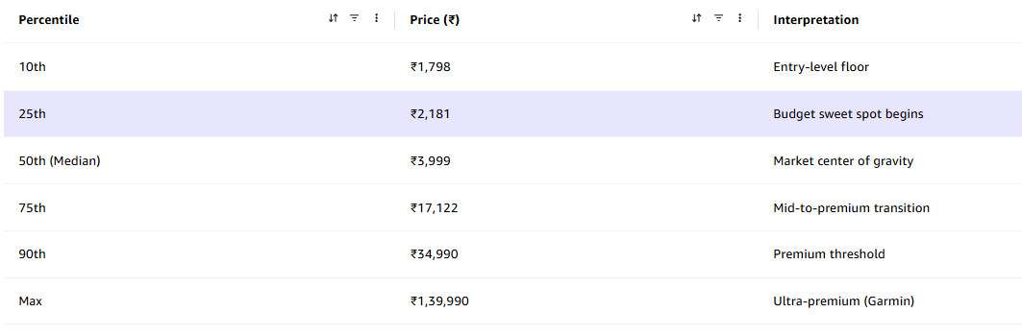
Figure 6: Price Distribution Percentile Table. Median at ₹3,999 confirms budget dominance; 75th percentile at ₹17,122 marks mid-to-premium transition zone.
The recommended entry point of ₹10,000–₹15,000 sits between the 66th and 72nd price percentile—squarely in the upper mid-tier. At this level, a new entrant is targeting the top third of the market by price point, where consumers have demonstrated willingness to pay for quality above the commodity floor, without requiring the brand equity investment needed to compete at the premium level.

Section 3: Opportunities and Risks
Building on the competitive landscape and trend analysis, this section provides a structured assessment of entry opportunities and risks across all three market tiers, culminating in the strategic recommendation with specific positioning guidance.

3.1 Tier-by-Tier Opportunity Assessment
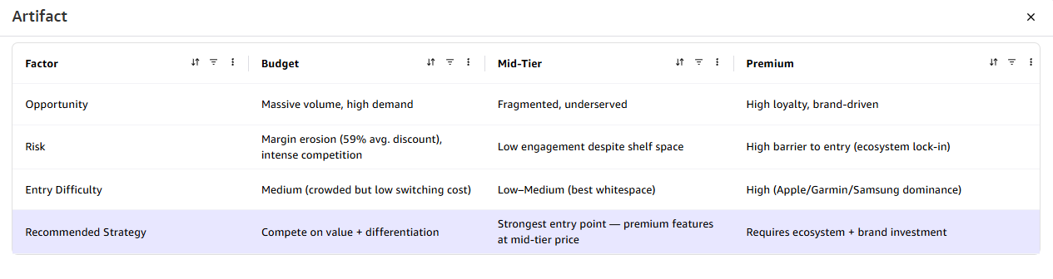
Figure 7: Market Positioning Strategy Matrix — Budget, Mid-Tier, and Premium entry difficulty vs. opportunity assessment.

Budget Segment — NOT RECOMMENDED
Despite the budget segment's massive volume (90% of consumer ratings, ~4M total ratings), it is structurally inhospitable for new entrants:
- Five Indian brands (Fire-Boltt, Noise, boAt, Pebble, Zebronics) have built scale advantages through years of aggressive SKU proliferation. Fire-Boltt alone lists 52 budget SKUs.
- 59.2% average discount with demand-weighted ASP of just ₹1,863. Any new entrant must match these discounts to compete for visibility, eliminating margin from day one.
- At ₹1,500–₹3,000, consumers make impulse purchases with minimal brand loyalty. Differentiation is virtually impossible at this price point.
- boAt's 72% average discount and Gizmore's 66% discount confirm that competition is on price, not value. Maximum discounts of 91% signal distress-level promotions.

BUDGET VERDICT: AVOID
The budget segment is a volume trap. High consumer engagement does not translate to commercial viability for a new entrant. Entering here requires matching incumbents' cost structures, SKU breadth, and distribution depth — none of which is achievable without multi-year investment and scale.

Mid-Tier Segment — RECOMMENDED ENTRY POINT
The mid-tier (₹5,000–₹20,000) is the most compelling opportunity in the market for a new entrant, based on five converging evidence streams:
Opportunity Factor | Metric | Strategic Implication
Fragmented competition | No brand >5% in mid-tier | No category leader to dislodge; entry does not require displacing an entrenched brand
Pricing stability | DW-ASP (₹13,642) > Simple ASP (₹12,931) | Consumers pay at or above average; promotional intensity is moderate (35% avg. discount)
Consumer satisfaction headroom | Avg. rating 4.1; max discount 61.7% | Strong quality perception exists; market is not saturated with high-satisfaction alternatives
Engagement gap | 22% listings, 5% ratings | Low engagement signals under-marketing by incumbents; marketing investment can disproportionately capture share
Feature differentiation space | Battery: 12.7 days avg.; circle dial 73.5% | Battery life improvement to 15+ days and premium stainless steel / leather design are viable differentiators

MID-TIER VERDICT: GO
The mid-tier is genuinely fragmented, under-engaged by incumbents, and exhibits pricing discipline that enables margin-positive entry. The ₹10K–₹15K price band sits at the 66th–72nd price percentile — accessible to aspirational consumers while retaining sufficient margin for brand-building investment.

Premium Segment — NOT RECOMMENDED (Initial Phase)
The premium segment (₹20,000+) offers the highest consumer satisfaction and strongest pricing power, but the barriers to entry are prohibitive for a new brand in the initial phase:
- Apple Watch requires iPhone; Samsung Galaxy Watch integrates deeply with Samsung Galaxy. These ecosystems create switching costs that a standalone wearable brand cannot match.
- Garmin's premium position is built on decades of outdoor/navigation heritage. Apple's 2% discount rate reflects brand equity that cannot be manufactured quickly.
- Premium materials, advanced health sensors (ECG, SpO2, GPS), and durability requirements significantly increase bill-of-materials, requiring high confidence in volume to amortise.
- The premium segment is an appropriate Phase 2 aspiration (3–5 years post-launch) once mid-tier brand equity has been established. Data confirms premium consumers are highly loyal (avg. rating 4.4, Apple 5.0).

PREMIUM VERDICT: DEFER (Phase 2 Aspiration)
The premium segment is not viable for initial market entry but represents the logical long-term trajectory after establishing mid-tier brand equity. Garmin, Apple, and Samsung own this space with defensible moats.

3.2 Risk Register
Despite the mid-tier GO recommendation, five material risks require active management:
Risk | Likelihood | Impact | Mitigation Strategy
Mid-tier structural smallness | Medium | High | Conduct pilot launch with 3–5 hero SKUs before full range expansion; use performance marketing to test elasticity
Budget brand upward migration | High | Medium | Anchor product positioning on quality (materials, battery, brand story) — not on price. Avoid competing on discount depth.
Premium downward pressure (Samsung/Fitbit) | Medium | Medium | Target ₹10K–₹13K sweet spot, deliberately below Samsung/Fitbit lower bound (~₹18K–22K after typical discounts)
Consumer discovery / low organic traffic | High | High | Invest in platform advertising (Flipkart Ads, Amazon Ads), influencer seeding in fitness/health verticals, and review generation programmes
Data limitation (snapshot only) | N/A | Low | Commission quarterly sell-through data from platform analytics to supplement the cross-sectional listing dataset. Track mid-tier ratings velocity over time.

3.3 Strategic Recommendation and Positioning Blueprint
The data supports a clearly defined Go-to-Market position for a new entrant in the India e-commerce smartwatch channel:
Parameter | Recommended Positioning
Entry Price Range | ₹10,000–₹15,000 (ASP target ₹12,000–₹13,000)
Tier | Upper mid-tier (66th–72nd price percentile)
Dial Design | Circular dial — aligns with mid-tier design language (73.5% of mid-tier SKUs); signals premium positioning vs. budget square/rectangular forms
Case Material | Stainless steel case option as premium anchor (14% of mid-tier SKUs use premium materials); differentiates from plastic-body budget competition
Battery Life | 15+ days target — outperforms mid-tier average (12.7 days) and matches premium tier (14.7 days); strongest functional differentiator available
Discount Strategy | Limit discounts to 20–25% maximum; maintain price integrity to signal quality and avoid race-to-bottom. Mid-tier incumbent average: 35%.
SKU Strategy | Launch with 3–5 hero SKUs (avoid budget-style SKU proliferation); depth over breadth in initial phase
Target Customer | Budget-to-mid upgraders (graduating from ₹1,500–₹3,000 products) seeking quality improvement; health/fitness-conscious urban consumers; first-time smartwatch buyers with ₹10K+ discretionary budget
Platform Priority | Amazon India primary (broader reach); Flipkart secondary. Both platforms show mid-tier presence in dataset.
Competitive Benchmarks | Direct: Amazfit (₹10,085 ASP), Honor (₹10,374 ASP). Aspirational comp: Samsung Galaxy Watch (₹24,490 median)

WHY ₹10K–₹15K SPECIFICALLY?

1. This range sits above the budget ceiling (₹5K) where margin destruction occurs, but well below the premium floor (₹20K) where ecosystem barriers become prohibitive.
2. Amazfit (₹10,085) and Honor (₹10,374) are the only established brands at this exact level, and neither holds more than 2–3% dataset share — confirming genuine whitespace.
3. The demand-weighted ASP for mid-tier (₹13,642) confirms this is where mid-tier consumers actually spend, not just browse.
4. A ₹12,500 hero SKU priced at 20% below Fossil (₹15,233) and Huawei (₹15,159) enables a clear "better value" narrative against mid-tier incumbents while remaining far above budget territory.

Section 4: Supporting Evidence Summary
This section provides a structured evidence map linking each strategic claim in this report to specific quantitative findings from the dataset and corroborating external Quick Research outputs. This ensures full traceability between conclusions and underlying data.

4.1 Evidence Map: Strategic Claims and Data Support
Strategic Claim | Dataset Evidence | External Research Corroboration
Budget is dominated by Indian brands | Fire-Boltt 13.3%, Noise 9.6%, boAt 7.1%; combined ~30% of all listings | "Indian budget brands dominate — Fire-Boltt, Noise, boAt together ~30% listing share"
Mid-tier is genuinely fragmented (no dominant player) | Largest mid-tier brand: Fossil at 5.1% dataset share; 13 brands compete at ₹5K–₹20K | "Mid-tier is fragmented — Amazfit, Huawei, Honor, Fitbit each 3–5%"
Premium is locked by Apple/Garmin/Samsung | Garmin 34 premium SKUs (7.6%), Apple 26 (5.8%), Samsung 16 (3.6%) in premium tier | "Premium dominated by Garmin (34 SKUs), Apple (26), Samsung (16)"
Budget pricing is unsustainable (62% gap) | Budget avg. original price ₹6,972 vs. selling price ₹2,631 = 62% gap; DW-ASP ₹1,863 | "Price erosion severe: original prices avg. ₹6,972 sell at ₹2,631 — 62% gap signals unsustainable margin pressure"
Mid-tier has stable pricing discipline | Mid-tier DW-ASP (₹13,642) closely matches simple ASP (₹12,931); 35% avg. discount vs. 59% in budget | "DW-ASP (₹13,642) closely matches simple ASP (₹12,931), suggesting consistent pricing discipline and less promotional warfare"
Apple maintains strongest price integrity | Apple avg. discount: 2%; rating 5.0/5; ASP ₹43,161 | "Apple discounts only 2% on average — the strongest price integrity in the market"
Garmin commands highest ASP (₹45,227) | Garmin: 38 priced products, median ₹39,490, range ₹16,990–₹1,39,990 | "Garmin commands the highest ASP (₹45,227) anchored by outdoor/fitness niche"
Budget captures 90% of consumer engagement | Budget total ratings: 4,038,046 (of ~4.49M total); avg. 18,355 per product | "Budget dominates with 57.3% of all products and ~90% of total consumer ratings"
Mid-tier is under-engaged relative to shelf space | Mid-tier: 22.3% listings but only ~5.2% of ratings; avg. 2,841 ratings/product | "Lower consumer engagement relative to shelf space — 22.3% of listings, only ~5% of total ratings"
Premium has highest satisfaction (avg. rating 4.4) | Premium avg. rating 4.4; Apple 5.0; vs. budget 3.9 and mid-tier 4.1 | "Premium: highest average rating (4.4), indicating strong customer satisfaction"
Circle dial is the mid-tier design standard | 73.5% of mid-tier SKUs use circle dial; vs. budget square/rect 84% | "Circle dials dominate [mid-tier] (73.5%), with premium materials like stainless steel (14%) and leather (12.8%) appearing"
Battery life is a mid-tier underperformance opportunity | Mid-tier avg. battery: 12.7 days vs. budget 14.4 days and premium 14.7 days | No explicit external source; derived purely from dataset. Corroborated by premium Garmin battery leadership.
Market median is ₹3,999 (budget-concentrated) | 50th price percentile: ₹3,999; 75th percentile: ₹17,122 | "Demand-weighted ASP of ₹4,145 — 67% lower than simple ASP — confirming overwhelming majority of purchases in budget"
GO recommendation: mid-tier ₹10K–₹15K | Mid-tier: fragmented (no dominant brand), stable pricing, 4.1 avg. rating, DW-ASP ₹13,642 confirms consumer willingness to pay | "Mid-tier: STRONGEST ENTRY POINT — fragmented, underserved; entry difficulty: Low–Medium; opportunity: high"

4.2 Chart and Image Reference Index
All seven charts and images provided in the dataset analysis are referenced within this report. The table below maps each visual to its source analysis and its location in the document:
Figure | Title / Description | Source | Key Data Point Illustrated
Fig. 1 | Vendor Share Pie — 18 brands, 450 listings | Dataset (brand listing count) | Fire-Boltt 13.3% leads; mid-tier fragmented at 2–5% each
Fig. 2 | ASP by Brand — horizontal bar | Dataset (avg. current price) | ₹1,799 (Hammer) to ₹45,227 (Garmin); entry zone ₹10K–15K is sparse
Fig. 3 | ASP Simple vs. DW-ASP by tier — grouped bar | Dataset (ratings-weighted price) | Mid-tier DW-ASP ₹13,642 > simple ASP ₹12,931 (pricing health signal)
Fig. 4 | Avg. and Max Discount % by tier — grouped bar | Dataset (discount rate) | Budget avg. 59.2% max 91%; mid-tier avg. 35.1%; premium avg. 12.9%
Fig. 5 | Consumer Engagement: Avg. Ratings/Product by tier | Dataset (ratings count) | Budget 18,355 vs. mid-tier 2,841 (6.5x gap)
Fig. 6 | Price Distribution Percentile Table | Dataset (price percentiles) | Median ₹3,999; 75th percentile ₹17,122; entry zone at 66th–72nd percentile
Fig. 7 | Market Positioning Strategy Matrix | Dataset + analysis | Mid-tier: lowest entry difficulty / highest opportunity; budget: medium; premium: high difficulty

4.3 Data Limitations and Analytical Caveats
The following limitations should be considered when interpreting the findings and recommendation in this report:
- Cross-sectional snapshot: The dataset represents a single point-in-time listing snapshot from Indian e-commerce platforms. It does not contain time-series data, meaning ASP trends, discount trajectories, and engagement velocity over time cannot be assessed from this dataset alone.
- India e-commerce channel only: Findings are specific to Flipkart/Amazon online channel. Offline/brick-and-mortar dynamics (which may represent 40–60% of India smartwatch market volume) are not captured.
- Ratings as demand proxy: Consumer ratings count is used as a proxy for unit sales, as no actual sell-through data is available. This proxy may overweight products with longer listing histories or aggressive review-generation campaigns.
- Global context not in scope: External research findings describe India-specific dynamics; the dataset does not include global unit shipment, revenue market share, or cross-country comparison data from industry analysts (IDC, Counterpoint, Canalys).
- 440 priced products vs. 450 total: 10 products in the dataset do not have listed prices and are excluded from all price and ASP calculations.

Appendix: Complete Brand Reference Table
Full dataset summary by brand, including product count, ASP, median price, price range, average discount, and average rating. Sorted by ASP (highest to lowest) to illustrate the market tier spectrum.
Brand | Products | ASP (₹) | Median (₹) | Price Range (₹) | Avg. Discount | Avg. Rating
Garmin | 38 | 45,227 | 39,490 | 16,990–1,39,990 | 16% | 4.0
Apple | 26 | 43,161 | 41,900 | 22,900–89,900 | 2% | 5.0
Samsung | 29 | 25,312 | 24,490 | 11,999–49,999 | 28% | 4.0
Fitbit | 20 | 17,698 | 18,849 | 8,999–26,499 | 23% | 4.0
Fossil | 24 | 15,233 | 14,995 | 9,198–23,995 | 38% | 4.0
Huawei | 15 | 15,159 | 14,990 | 6,400–29,999 | 40% | 4.0
Honor | 14 | 10,374 | 10,023 | 2,199–17,999 | 20% | 4.0
Amazfit | 14 | 10,085 | 8,249 | 2,999–19,999 | 34% | 4.0
Crossbeats | 4 | 4,249 | 3,999 | 2,999–5,999 | 62% | 4.0
Noise | 43 | 4,029 | 1,799 | 1,299–82,990 | 60% | 4.0
Pebble | 32 | 3,637 | 3,999 | 1,499–5,190 | 44% | 4.0
Fire-Boltt | 59 | 3,280 | 3,299 | 1,299–6,999 | 65% | 3.0
Dizo | 24 | 3,011 | 2,749 | 1,199–5,999 | 43% | 4.0
Zebronics | 32 | 2,729 | 2,624 | 1,399–5,499 | 53% | 4.0
Gizmore | 23 | 2,321 | 1,999 | 1,199–6,999 | 66% | 4.0
boAt | 31 | 2,094 | 1,999 | 1,199–3,999 | 72% | 4.0
Ambrane | 11 | 1,896 | 1,799 | 1,299–2,499 | 61% | 4.0
Hammer | 1 | 1,799 | 1,799 | 1,799–1,799 | 64% | 4.0

Colour coding: Green = Premium tier (> ₹20K); Orange/Yellow = Mid-tier (₹5K–₹20K); Red = Budget (< ₹5K)

Note: 440 of 450 listings have prices; 10 excluded from ASP calculations. "Products" reflects all listings including unpriced. Brand-level ratings averages shown as rounded values. External Quick Research findings sourced from conversational research outputs provided by the user.

